**Aim:**

# a. Progress bar

# b. Tool Tip

# c. Picture box

**OUTPUT:**

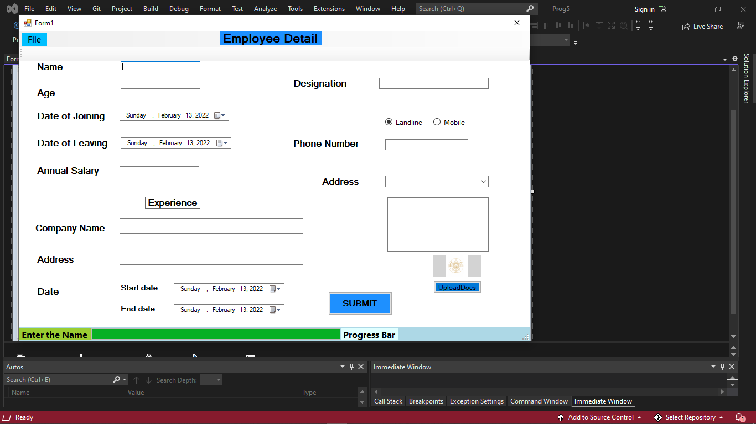

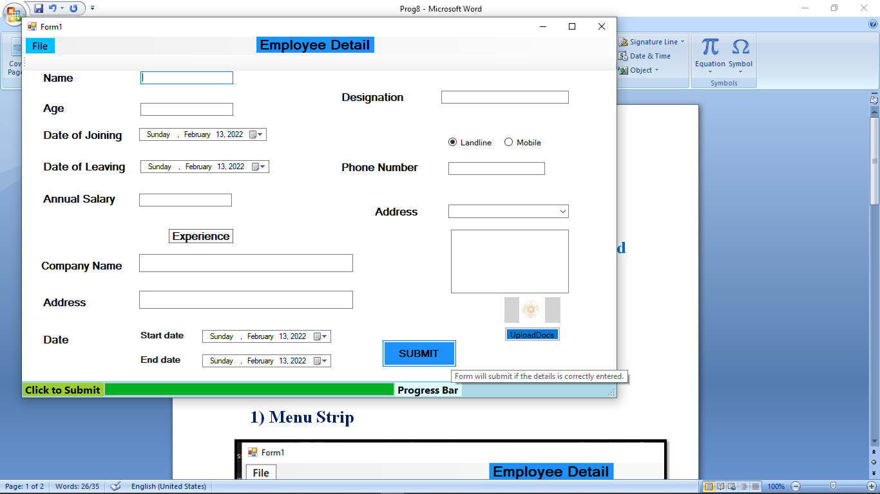

**CODE:**

